



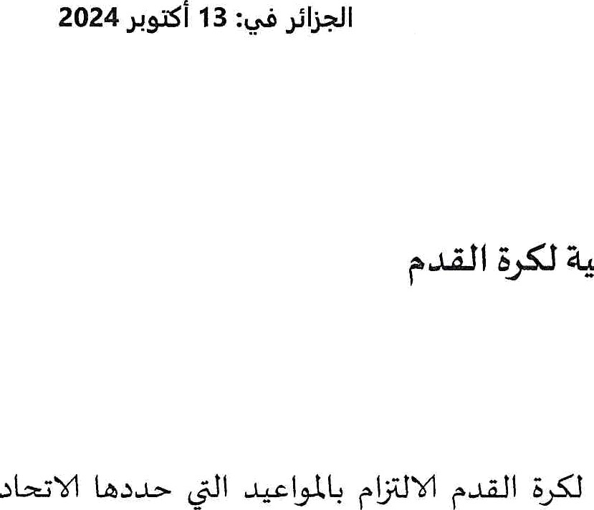

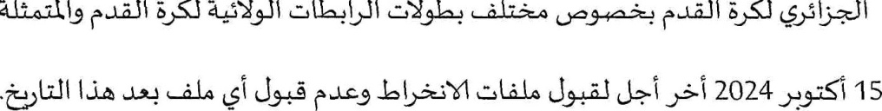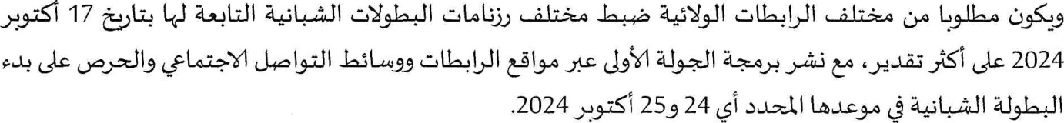

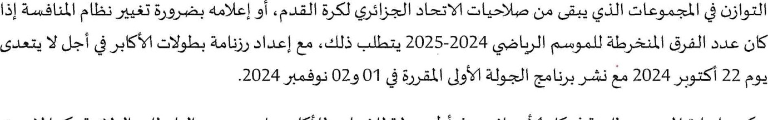

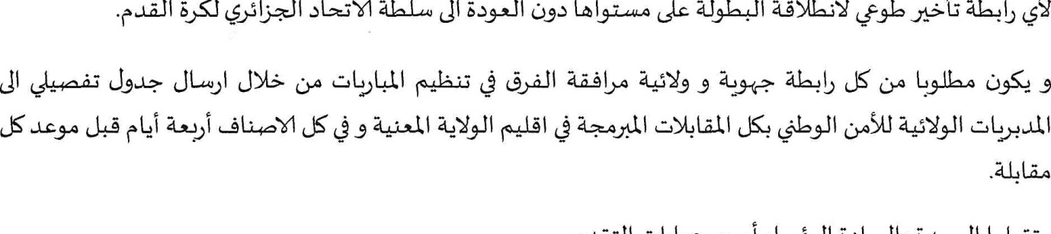



ied Ouaked St, PO Box 39 Dély Brahim - Algiers

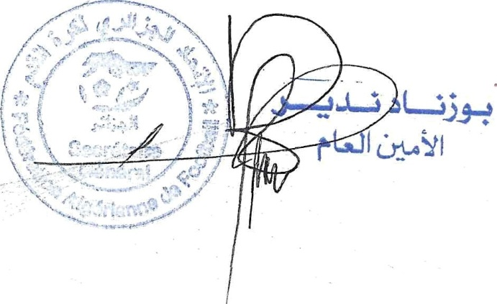w21Z20z1812Z

+2l3 2O31 812} -

[sgfaffoot@grnail.com](mailto:sgfaffoot@grnail.com)

[www.faf.dz](http://www.faf.dz/)